**ReadMe_BS_Filter - ChatGPT**

1. **Library and Use Clauses**: The code includes the necessary library and use clauses to import the required packages for the design.
2. **Entity Declaration**: The entity declaration for "**BS_Filter**" specifies the input and output ports of the module. The module has the following ports:

* "**resetn**": An asynchronous active-low reset signal.
* "**sysclk**": The system clock signal.
* "**bi_phase_out**": The input signal to be filtered.
* "**signal_out**": The filtered output signal.

1. **Architecture Declaration**: The architecture is named "**ab**" and defines the internal implementation of the "**BS_Filter**" module.
2. **Signal Declarations**: The code includes signal declarations for various signals used within the architecture.

* "**sig_filter**": A 8-bit vector used as a shift register to store the history of input signals.
* "**sig_check_0**" to "**sig_check_6**": Individual signals representing the XOR outputs of consecutive elements of the "**sig_filter**" vector.
* "**sig_total_check**": A signal used to determine the total check result based on the XOR outputs.

1. "**signal_in**" Process: This process is sensitive to changes in the "**resetn**" and "**sysclk**" signals. It initializes the "**sig_filter**" signal to all zeros during reset and shifts the "**bi_phase_out**" input into the "**sig_filter**" vector on every rising edge of the "**sysclk**" signal.
2. "**xor_debouncer**" Process: This process is responsible for debouncing the "**sig_filter**" vector. During reset, it sets all the "**sig_check**" signals to '1'. On every rising edge of "**sysclk**", it performs XOR operations on consecutive elements of "**sig_filter**" to calculate the "**sig_check**" signals. If will be 2 elements that different from each other's this "**sig_check**" will be '1' because of the XOR operation, that mean that we have change in the "**bi_phase_out**" signal. In another case "**sig_check**" will be '0' mean have no change in "**bi_phase_out**" signal.
3. "**main_check**" Process: This process determines the total check result based on the "**sig_check**" signals. During reset, "**sig_total_check**" is set to '1'. On each rising edge of "**sysclk**", if any of the "**sig_check**" signals is '1', indicating a change in the input signal, "**sig_total_check**" is set to '0' if indicating a no change in the input signal "**bi_phase_out**". Otherwise, it remains '1'.
4. "**signal_out**" Process: This process is responsible for generating the filtered output signal. During reset, "**signal_out**" is set to '0'. On each rising edge of "**sysclk**", if "**sig_total_check**" is '0', indicating a no change in the input signal, "**signal_out**" is updated with the current value of "**bi_phase_out**".

Overall, this architecture implements a debouncing filter using XOR operations on consecutive elements of the input signal history. The filtered output signal is generated when a change in the input signal is detected, and the total check result is '0' when a no change signal has been detected and "**signal_out**" is updated with the current value of "**bi_phase_out**", else indicating a change in the input signal "**bi_phase_out**" and "**signal_out**" isn't updated with the current value of "**bi_phase_out**".

**XOR - chatGPT**

In scientific literature, XOR (Exclusive OR) is a logical operation that is commonly studied in the field of computer science, mathematics, and information theory. It is often discussed in the context of Boolean algebra and binary logic. XOR is a binary operation that takes two binary inputs and produces an output based on the following rule:   
  
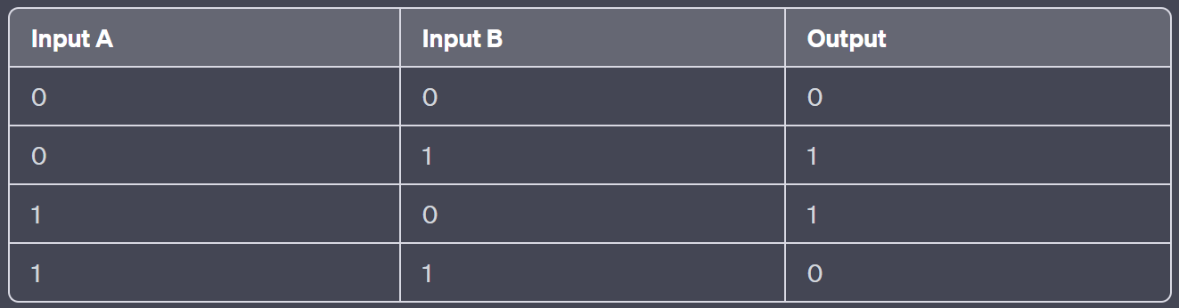  
  
the output is true (1) if the number of true inputs is odd, and false (0) if the number of true inputs is even.

XOR has various applications in computer science, including digital logic design, computer architecture, and cryptography. It is a fundamental building block in designing logical circuits and is used in combinational logic circuits to perform operations such as data comparison, error detection, parity generation, and more.

In the field of cryptography, XOR is utilized in symmetric encryption algorithms, such as the Data Encryption Standard (DES) and the Advanced Encryption Standard (AES). XOR operations play a crucial role in achieving encryption, decryption, and key generation processes.